|  |  |
| --- | --- |
| EX NO: 1 | DESIGN A WEB PAGE USING HTML TAGS AND HOST IT IN SERVER |
| DATE:19.6.18 |

AIM :

To design a webpage using html and host it in the internet using 000webhost server.

PROCEDURE:

STEP 1: Write the program in the notepad.

STEP 2: Save it in the xamp folder

STEP 3: then output was executed in the browser(intranet)

STEP 4: using 000webhost the ouput was displayed (internet)

PROGRAM :

<!DOCTYPE HTML PUBLIC "-//W3C//DTD HTML 4.01 Transitional//EN"><html><head><META http-equiv="Content-Type" content="text/html; charset=utf-8"></head><body>

<div>

&lt; table border =&quot;1&quot;&gt;

<table><caption><strong><a href="http://s.no" target="_blank">s.no</a>(1st column)and subjects(2nd column)

and Marks(3nd column)</strong></caption>

<thead>

<tr>

<th><a href="http://s.no" target="_blank">s.no</a></th>

<th>subject</th>

<th>marks</th>

</tr>

</thead>

<tbody>

<tr>

<td>1</td>

<td> Mathematics-3</td>

<td> 80</td>

</tr>

<tr>

<td>2</td>

<td> Dta structures -1</td>

<td> 50</td>

</tr>

<tr>

<td>3</td>

<td> Object Oriented Programming</td>

<td> 75</td>

</tr>

<tr>

<td>4</td>

<td> Digital Principles </td>

<td> 80</td>

</tr>

<tr>

<td>5</td>

<td> Computer Organisation</td>

<td> 60</td>

</tr>

<tr>

<td>5</td>

<td> Communication Engineering</td>

<td> 50</td>

</tr>

</tbody>

</table>

&lt; table border =&quot;2&quot;&gt;

<table><caption><strong><a href="http://s.no" target="_blank">s.no</a>(1st column)and subjects(2nd column)

and Marks(3nd column)</strong></caption>

<thead>

<tr>

<th><a href="http://s.no" target="_blank">s.no</a></th>

<th>subject</th>

<th>marks</th>

</tr>

</thead>

<tbody>

<tr>

<td>1

<td> Mathematics-4</td>

<td> 85</td>

</td></tr>

<tr>

<td>2</td>

<td>Dta structures -2</td>

<td>80</td>

</tr>

<tr>

<td>3</td>

<td>Java Programming</td>

<td>70</td>

</tr>

<tr>

<td>4</td>

<td>Data Base Management System </td>

<td>82</td>

</tr>

<tr>

<td>5</td>

<td>Operating System</td>

<td>90</td>

</tr>

<tr>

<td>6</td>

<td>Software Engineering</td>

<td>66</td>

</tr>

</tbody>

</table>

</div>

</body></html>

OUTPUT:

USING INTRANET

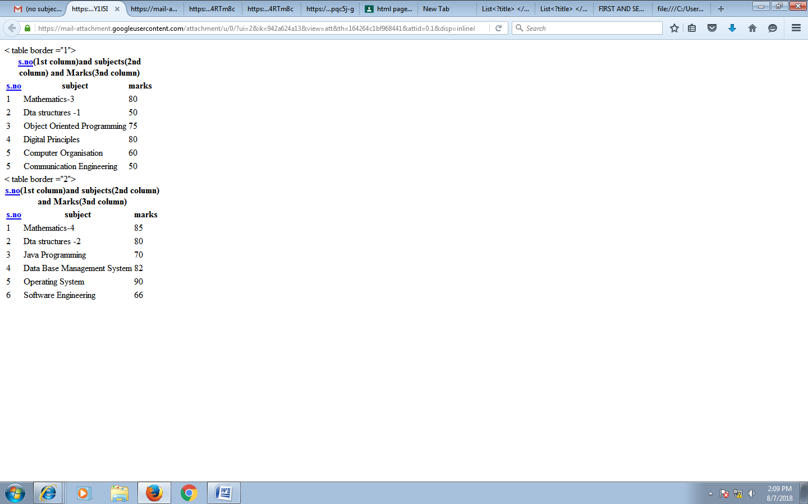

USING INTERNET

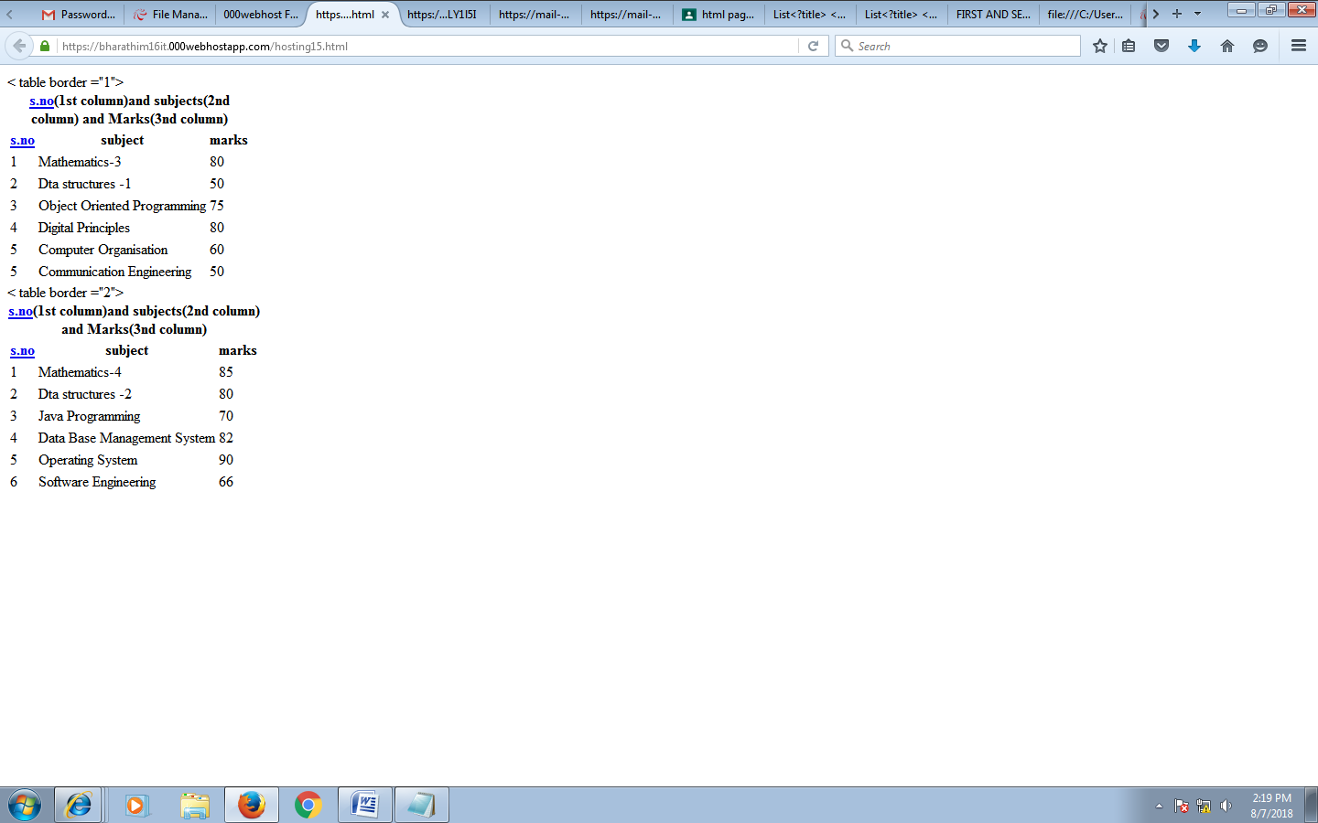

RESULT :

Thus web page was created using internet and intranet